Solo Sokos Hotel Vasilievsky

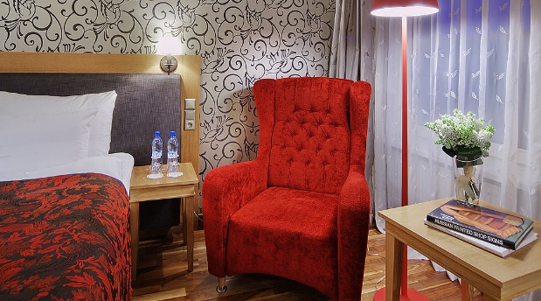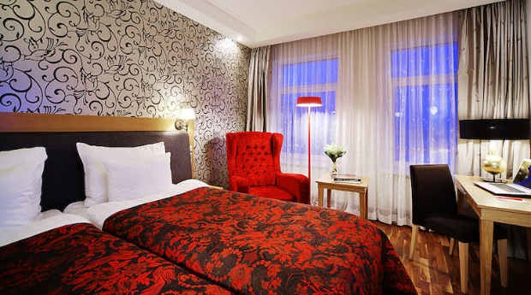

Description:
Sokos Hotel Vasilievsky has become a part of historic center of St. Petersburg.
The hotel provides old-fashioned, cosy atmosphere with 255 rooms.
It is located on 8th Liniya of Vasilivsky Island, and occupies recently refurnished building, built in XIX century.
Thanks to comfortable location, Sokos Hotel Vasilievsky can become a starting point for walking trips in St. Petersburg, that are very appreciated by guests of our city.
The hotel has a business center, well-equipped gym, sauna as well as 30 underground parking spaces.
Sokos Hotel Vasilievsky provides 255 rooms. All rooms are equipped with shower and almost all with bath.
The beautiful, stylish and spacious rooms have all necessary facilities and technical outfits, including Internet access through Wi-Fi connect.

Prices:
Room category | Room rate,rur
Solo king | from 10700
dbl stand | from 10700

Web: https://www.sokoshotels.fi/en/st-petersburg/sokos-hotel-vasilievsky
Address: V.O. (Vasilievskiy Ostrov), 8th Liniya, 11-13
St. Petersburg, 199034, Russia
_______________________________________________________

Shelfort
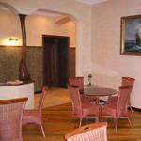 | 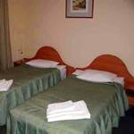 | 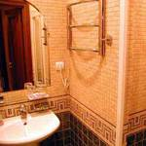
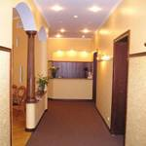 | 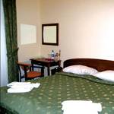
Description:
Hotel Shelfort is located in the historical center of Saint-Petersburg close to the most beautiful place of Northern Capital.
Shelfort, opened in 2001 is a small cozy hotel of business class of 3 stars category with 15 rooms. In Shelfort hotel there are two two-room suites with the ancient operating fireplaces in the halls. This will help you feel yourselves much more comfortable. There are also two standard single rooms, two single comfort rooms and nine double rooms. We can offer you rooms with separate beds, and with a king-size bed. Each room is equipped by the TV and phone.
We can provide a meeting at the airport or at the railway station, organize excursions, order avia-, railway and theatre tickets. We accept the basic credit cards.
The breakfast is served at time, that is convenient for the Guest. There is 24-hour room service in our hotel.
There is an ancient fireplace in the hall of the first floor, this allows our Guests to spend evenings with a coziness. Constantly there are skilled Administrators on each floor of Shelfort hotel. The hotel is provided by round-the-clock guard.

Prices:
Room category | Room rate,rur
single stand | 4020
single comfort | 4500
double standart | 6600
suite | 8340

Web: http://www.shelfort.ru/en/

Address: V.O. (Vasilievskiy Ostrov), 3rd Liniya, 26,
St.Petersburg, 199004, Russia
_______________________________________________________

Trezzini
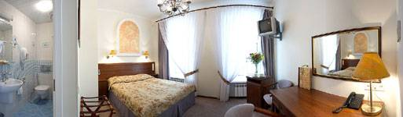
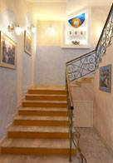 | 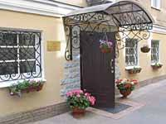 | 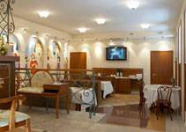
Description:
Trezzini hotel is a small 17 room hotel in the very heart of Vasilievsky island. It is called after the Italian architect Domenico Trezzini who developed the first general plan of St.Petersburg more than 290 years ago. The hotel is located at the crossing of 6th Line and Bolshoy prospect with its major windows overlooking St.Andrew's Church.
Facilities: air-conditioner, telephone, free internet, satellite TV (16 channels), bath, shower, refrigerator, mini-bar, hair-drier, safe deposit in each room, room service, conference room (space for 8-10 people), baby bed, laundry, baggage room, kitchen.

Prices:
Room category | Room rate,rur
econom | 6700
classic1 | 7700
classic2 tw/dbl | 8600

Web: http://www.trezzini-hotel.com/index-eng.htm

Address: V.O. (Vasilievskiy Ostrov), Bolshoy prospect, 21,
St.Petersburg, 199004, Russia
_______________________________________________________

Pushka Inn
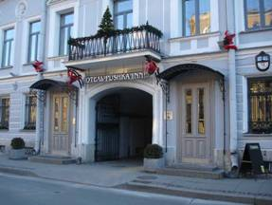 | 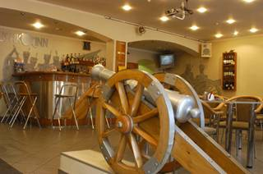
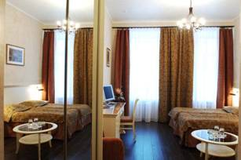
Location of the hotel: the building is an architectural monument of the XVIII century, situated in the historical part of the city, 5 minutes walk from Hermitage and Palace Square, with a splendid view on the Moyka Embankment from the windows. Near Nevsky prospect. Moyka,12 ( next building- is the Pushkin historical apartment where poet lived with his wife Natalia and children )
Pulkovo airport: 50 minutes by car.
Moscow railway station: 15 minutes by car.
Number of rooms of the hotel: 34 rooms: 5 single econom, 16 double standards, 8 comfort, 5 family.
Hotel services: 24 hour service, security, restaurant, secure inner yard, parking, luggage cloack-room.
Room facilities: bathroom, telephone, satellite TV, direct access to Internet (ADSL), air conditioning.
Prices:
Room category | Room rate,rur
single economy | 7000
standard | 10500
standard + | 11500
comfort | 13500
comfort room with  the balcony | 15000

Web: http://www.pushka-inn.com/
Address: 14, Moyka river embankment,
Saint-Petersburg, Russia, 191186
GPS: N 59°56'27.68", E 30°19'14.01"
_______________________________________________________

Park Inn by Radisson Pribaltiyskaya

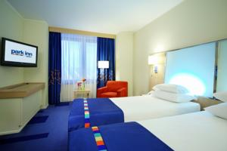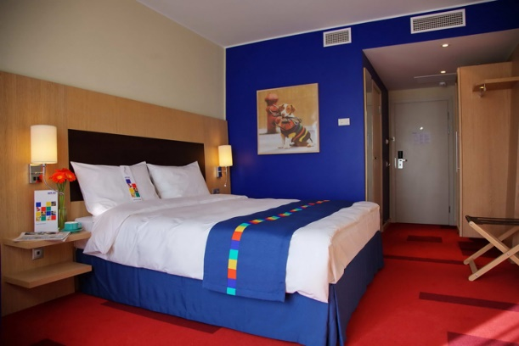
Overlooking the Gulf of Finland, the Park Inn by Radisson Pribaltiyskaya is conveniently located just 10 minutes from the heart of St. Petersburg. The hotel provides easy access to Pulkovo Airport as well as unforgettable attractions like the Hermitage Museum and the historic Mariinsky Theatre.
Bright and inviting, this St. Petersburg accommodation features vibrant colours, sleek lines and spectacular views of either the city centre or the Gulf of Finland.All 1,193 guest rooms include a variety of outstanding amenities, such as satellite TV, 24-hour room service and Free Wireless High-speed Internet. Dedicated to taking care of every detail, the hotel also offers laundry, dry cleaning and tailoring services.
Prices:
Room category |  | Room rate,rur
Save 10%-STANDARD ROOM |  | 7110
STANDARD ROOM - BREAKFAST INCLUDED |  | 7900
JUNIOR SUITE - BREAKFAST INCLUDED |  | 11900
DUPLEX SUITE - BREAKFAST INCLUDED |  | 13900

Web: http://www.parkinn.com/hotelpribaltiyskaya-stpetersburg

Address: 14 Korablestroiteley Street
St. Petersburg 199226 Russia
Phone: +7 812 329 26 26
Fax: +7 812 356 60 94
Email: info.pribaltiyskaya@rezidorparkinn.com
_______________________________________________________

Rinaldi at Vasilievsky
This St. Petersburg hotel is located on Vasilievsky Island, 1.5 km from Palace Bridge and 3 km from LenExpo Exhibition Centre.
The Winter Palace and the State Hermitage Museum are a 30-minute walk from the Rinaldi Vasilevskom.
Vasileostrovskaya Metro Station is a 5-minute walk away.
Rooms at Rinaldi on Vasilevskom are simply furnished with wooden interiors. All rooms feature a TV, safe and private bathroom.
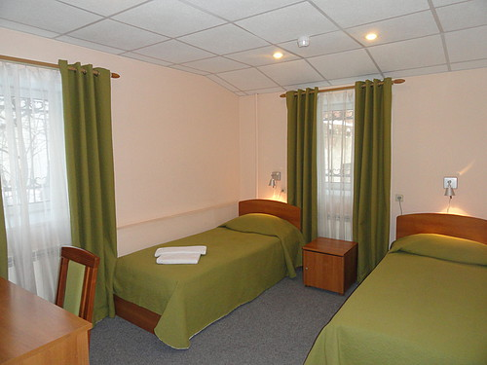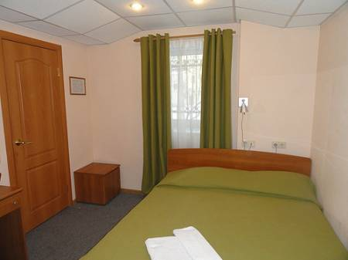

Prices:
Room category |  | Room rate,rur
Single standard room |  | 3400
Single standard room with double bed |  | 4200

Web: http://rinaldi.ru/hotels/rinaldi_vasilevsky

Address: 4 Liniya Vasilyevskogo Ostrova 13, Vasileostrovskiy district, 199034 Saint Petersburg

