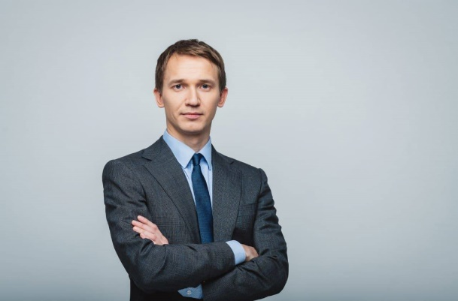

**Phone number** 8 (911) 353-00-05 **E-mail** [maksivanov@gmail.com](mailto:maksivanov@gmail.com) **Address** Russia, Saint Petersburg

@maxivanov

We recommend indicating only professional social networks in your resume

@maxivanov

(senior marketer)

**MAXIM IVANOV**

**ABOUT ME**

*In this section, we advise you to briefly describe your education, key competencies, area of interest and motivation for work..*

I am completing a master's degree in Corporate Finance and CEMS MIM at Graduate School of Management, St. Petersburg State University. The experience of studying abroad allows me to combine the best practices of Russian and foreign business. I want to build a career as a marketer in Russia. My strong personal qualities are curiosity, multitasking, willingness to share knowledge, and efficiency.

**ADDITIONAL EDUCATION**

**EDUCATION**

*2016*

**The course "How to become a marketer”**

Yandex.Practicum

Number of hours: 240

*2017*

**Marketing**

MAB Business School

Number of hours: 125

*2015-2017*

**GSOM SPBU**

Program: Management

Degree: Master

*2011-2015*

**GSOM SPBU**

Program: Management

Specialization: Marketing

Degree: Bachelor

**Work experience**

*2019 г.-present*

Full-cycle agency "N”

**Position:** Senior Consultant

*Tell about your functionality and key results.*

Conducted research on the main factors that shape the dynamics of consumer demand for products.

*2017-2019*

Studio "N”

**Position:** Marketing Assistant

*Tell about your functionality and key results.*

Conducted research on the main factors that shape the dynamics of consumer demand for products.



**ADDITIONAL ACTIVITIES**

*In this section, we recommend that you tell about your victories in case championships, student projects and research projects, as well as about your volunteer and organizational experience.*

**LANGUAGES**

English – C1

**SKILLS**

+ Marketing and advertising activities

+ Product Marketing

+ Comprehensive research

+ Creative Communications (SEM, SEO)

+ Brand Promotion

+ Positioning (B2B, B2C)

+ Pricing, budgeting

+ Media Planning

+ Consumer Psychology

**ДОПОЛНИТЕЛЬНАЯ ДЕЯТЕЛЬНОСТЬ**

Советуем вам рассказать здесь про победы на кейс-чемпионатах, студенческих проектах и написанных работах, про волонтерство и участие в организационных комитетах.

Spain – А1

**ЗНАНИЕ ЯЗЫКОВ**